**High-level design document**

**1.Outline design**

**1.1 game name:** World Conquest

**1.2 background overview:** the World conquest is a strategy board game, players strive for global domination by capturing domain and establishing foreign policy.

**1.3 genre:** board game

**1.4 selling points:**

1.4.1 configuration requirements: common operating systems can be supported, like Windows, macOS. Besides, the board games mainly rely on relatively simple graphical interface and fundamental user interaction.

1.4.2 interaction: this platform offers real-time translation services to facilitate the communication among individuals from diverse countries, thereby promoting the efficient within the game experience.

1.4.3 upload the initial data: in the game, there is a variety of cards and chess pieces that require management, which can be directly downloaded from the external files when the game is launched. It means that the game has a remarkable customization.

**1.5 target audience:**

**1.6 hardware requirements:**

* In general, it is appropriate for desktop computer. Ideally, it should be playable on PC.
* But there is no plan for portable version at this stage

**2.Operating environment:**

**2.1 development engine:** unity

**2.2 development language:** C#

**3.game mechanism:**

**3.1 background:** is a strategic map, displaying different areas and the outlines of lands and seas. Typically, regions are easily distinguishable due to the clarity of their boundaries and the use of brightness colors.

**3.2 prepare:**

3.2.1 map generate: load the game map, ensuring that there are 6 continents that the user can choose, including the classical map, Eurasia and some fantasy maps set according to the plot. And each continents have several countries.

3.2.2 player order: roll the dice, the order according to the size of the number of dice points, and the larger number of points is preferred.

3.2.3 color select: players should choose a color to represent their territories. For example, red, blue, yellow, green, black and white. The boundary between different territories should be legible by using distinct color to represent differences between military and regions, making players comprehend the whole world.

3.2.4 card distribution: count out the armies depending on the number of players.

* each player counts out 40 armies if there are 2 players
* each player counts out 35 armies if there are 3 players
* each player counts out 30 armies if there are 4 players
* each player counts out 25 armies if there are 5 players
* each player counts out 20 armies if there are 6 players

3.2.5 select module: each player selects a starting area as their headquarter at the beginning of the game and acquire a given resources and forces.

3.2.6 player state check: make sure all the players are already finished the preparation stage and can enter the next stage.

**3.3 proceed:**

turn: players experience conscription, occupation, and war sequentially

* conscription: at every turn beginning, count the number of territories that the players capture and then divide by three. The result is the number of the armies that the players can deploy in the next turn
* attack: the armies divide into three categories, infantry, cavalry (worth 5 infantry) and artillery (worth 10 infantry or 2 cavalry). The infantry with a gun in hand and cavalry on horseback. Players can use these armies to attack and choose those lands with a high chance of winning in terms of adjacent territory
* cards reward: the cards divide into four types. The first three type is a territory with an infancy, cavalry or artillery. The rest of one is a “wild” card with all three armies but no territory. Players can get a card if they successful occupy a territory. When players gain three cards of same armies type or three cards of random armies type or two random armies cards and one wild card, they can get some of troops in the next turn.
* territorial expansion: if the players win in this round, they can acquire the territories of opponents. But there is a certain army that need to remain in the conquered territory
* fortification: players can deploy their armies to place on captured territory. Move the armies to the front and fortify territories that border enemy territories are the good strategy to strengthen their defenses or prepare for the next attack.

**3.4 finish:**

3.4.1 victory: when the players conquer all the territories or has the maximum number of territories at a particular round win, a visual window will overlay the current screen, displaying the victory message

3.4.2 end: declare the winner of the turn

**4.UI design:**

**4.1 main menus:** the menu encompasses options of single player, multiplayer, load and setting, ensuring players can easily locate the requisite features.

4.1.1 new game:

* single player: when the user clicks the button, the loading screen will appear first and the page jumps to the single player interface. And then the user can play with AI
* multiplayer: when the user clicks the button, the players can choose to play with friends or match players online. In room-based multiplayer, one player creates a game room and limit the number of people in the room. The other players can access to the room through the list of rooms or an invitation link in the game interface. The game starts when the number of players in the room reaches a preset minimum number. When the game reaches the end condition, the game result will be settled, and the rewards will be distributed or ranked

•

4.1.2 load: players can revert to a previously saved state at any time whenever necessary, without having to start the game from scratch

4.1.3 language: the user can choose their first language or familiar one

4.1.4 settings: the user can see several options that enable players to adjust volume, background sound effects and other specific selections when they enter the settings interface. It is aimed at accommodating different player preferences. The following is an introduction of these buttons

* music options (BGM volume): the user can adjust the volume of music
* sound options (SE volume): the user can adjust the sound of a mouse click button
* display type: there are two choices, including windowed and full-screen and it is related to resolution. By default, it adapts automatically with the user's computer
* news: it is a chat interface between users and other players when they are playing the game. The chat box is located at the bottom left of the game screen, but not obstructing the core game content. Players can send messages by typing text in the input box and pressing the "Send" button, or by pressing a shortcut key (such as the Enter key).

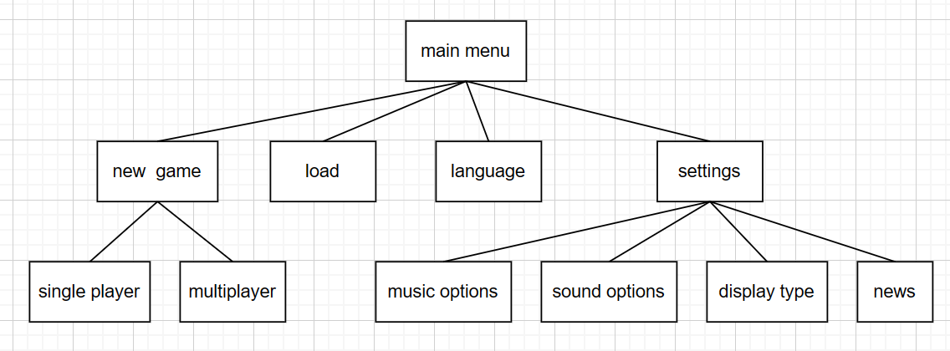

**4.2 game menus:**

4.2.1 pause: players can click the pause button and pause game while it is in progress. And the pause screen will appear, including options of restart, continue and return to the main menu

restart: players can quit their current game and begin a new round.

continue: players can return to the game interface where they recently engaged in the game

return: when players click this button, they can return to the main menu and quit the current round

4.2.2 settings: players can adjust the volume of music and sound, and the window size of game

4.2.3 save: save the current game progress of users for later resumption

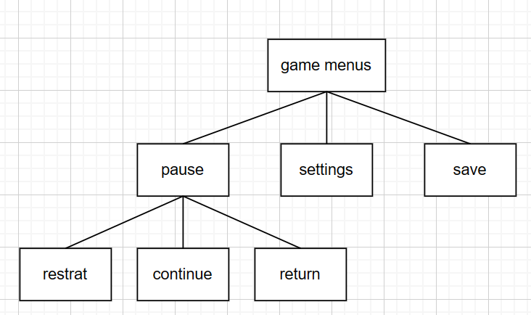

**4.3 AI design:**

4.3.1 temporal AI: temporal AI focuses on rapid decision-making and execution, making decisions based on factors such as territorial control, adversary and border armies in a limited time, based on the current situation. In terms of the reaction time of AI, it can adjust according to the complexity and players expectation. A timeout handling mechanism can be implemented if AI cannot make decision within the prescriptive time, such as randomly selecting a acquiesce behavior or skipping the turn

4.3.2 imitation AI: imitation AI is designed to imitate the behavior of adversaries and based on observed behaviors to develop its own strategy. Through a process of continuous feedback analysis during every gameplay to optimize performance in subsequent encounters

**5.data design:**

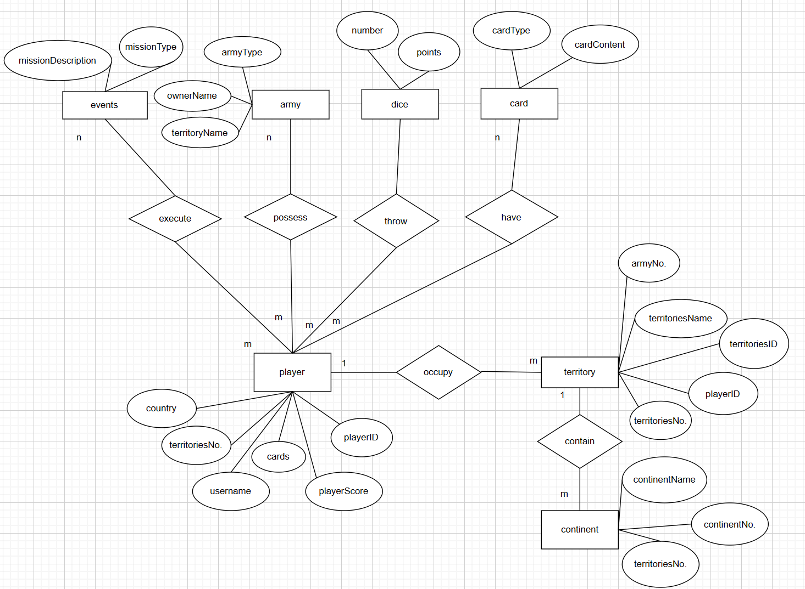

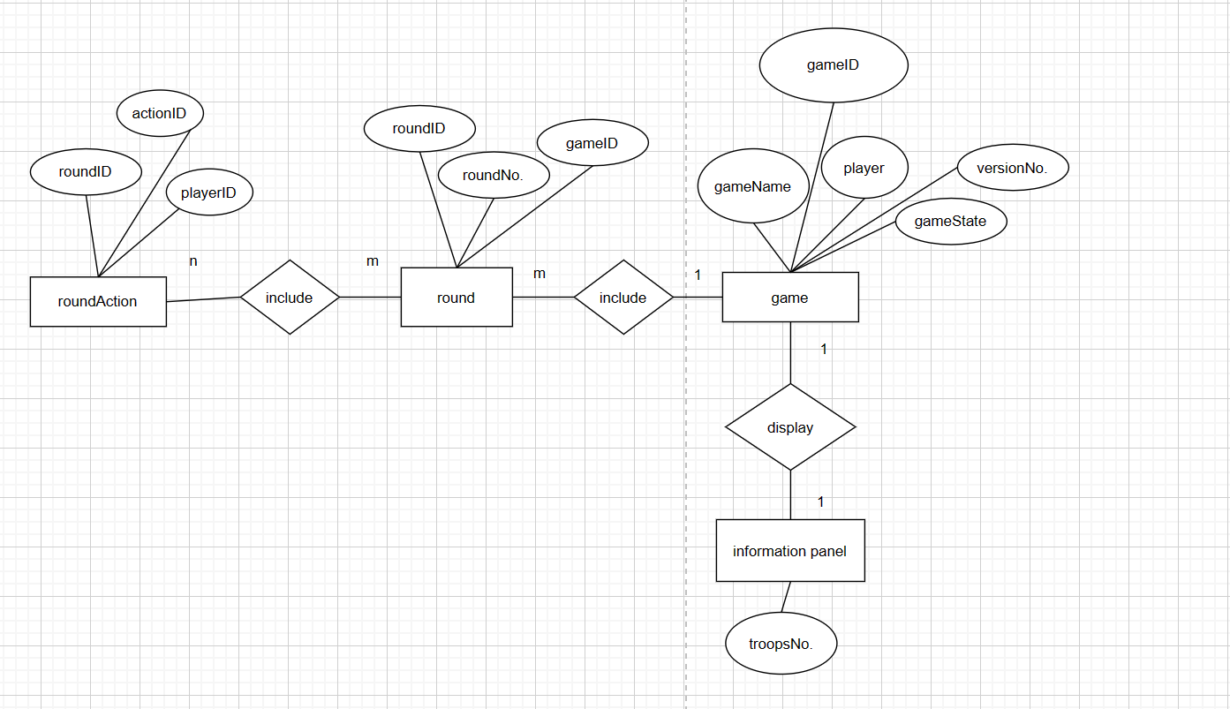

**6.animation:**

The animation is selected in a 2D style, portraying the grandeur of the landscape depicted on the map, along with the fluid movement of armies and seamless zooming capabilities. The duration of the opening animation should be kept at a moderate level to ensure player engagement without inducing impatience. Ideally, it should range from 30 seconds to 1 minute

**7.Sound and Music:**

**7.1 music:**

7.1.1 open screen music: employ epic compositions, such as symphonies or choruses, to inspire emotions and excitement in the player. The length of the music should be moderate, not too long to avoid boredom, generally between 30 seconds and 1 minute. The music should be played as soon as the game is started to guide the player into the atmosphere of the game

7.1.2 background music: the background music should be chosen according to the game situation, for example, when users engage in stimulating and activating tasks, the music should be excitable. Similarly, if the players are going to achieve victory and get the prize, the sound effects will show the music with a dense drumbeat or play cheerful victory sound effects, such as cheers, victory horns

**7.2 sound:**

7.2.1 percussion sound: instances of mournful scenes can have a musical accompaniment featuring the violoncello, which can contribute to the profound sense of irritation. On the contrary, scenes portraying positive emotion should accompany with a brisk music

7.2.2 interface sounds: interface sound effects should be concise and clear, but can clearly express the results of operations. For example, a slight click sound can be played when a button is clicked and play smooth transition sounds when the interface switches